NAAN MUDHALVAN PROJECT

Laptop Request Catalog Item

SERVICE NOW

LAPTOP REQUEST UPDATE SET

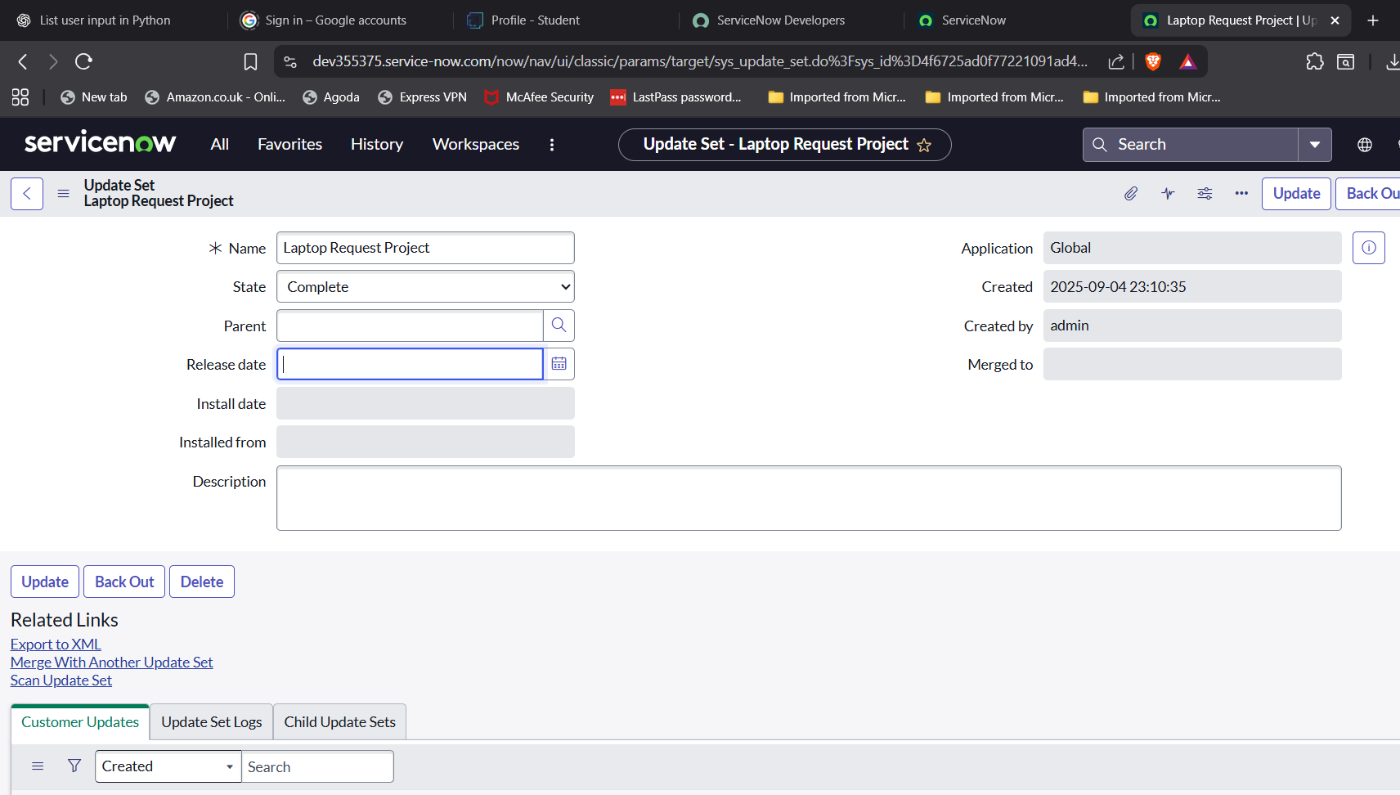

AFTER UPDATE SET RETRIEVE REQUEST:

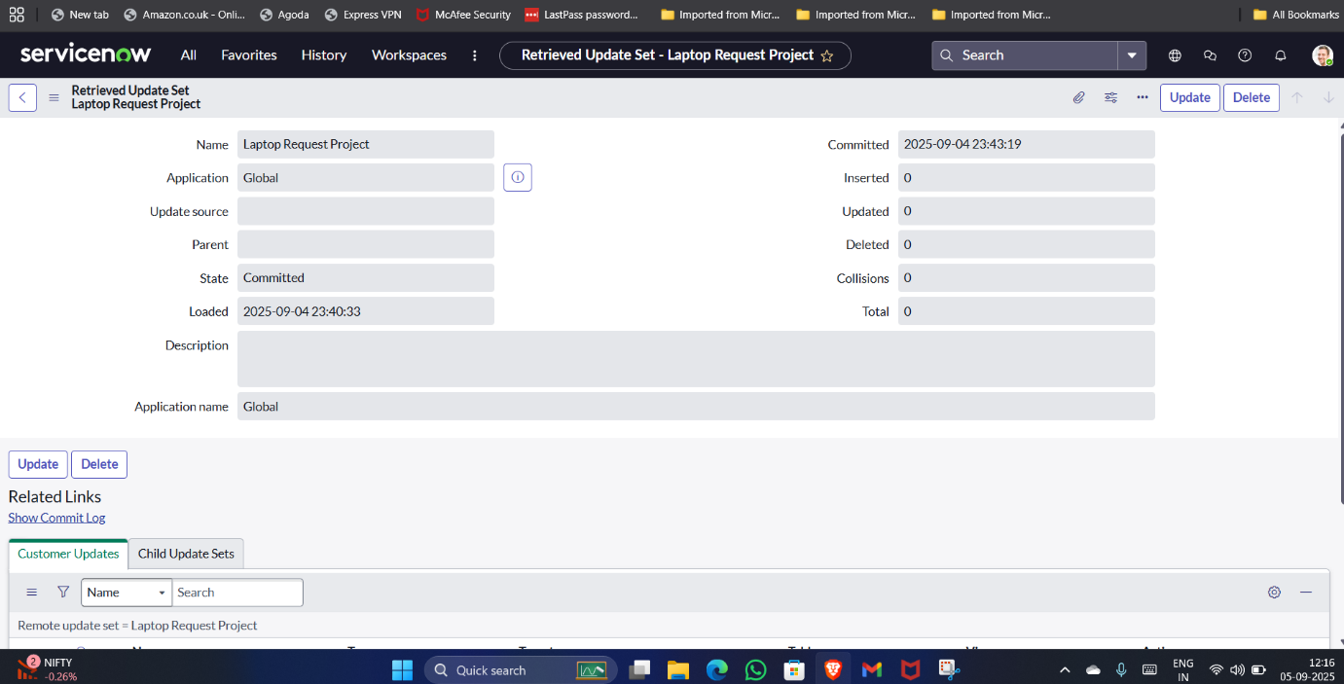

RETRIEVED UPDATE SETS(laptop catalog project is visible):

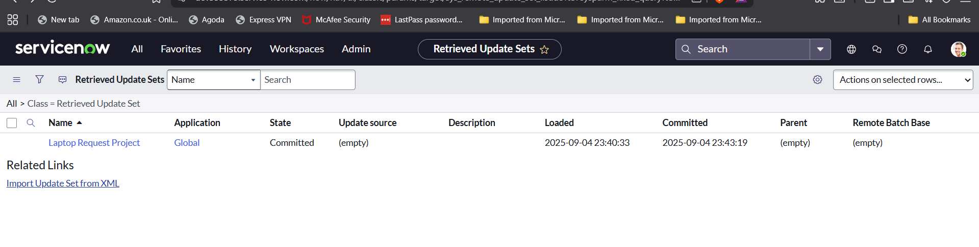

HERE THE LAPTOP REQUEST CATALOG:

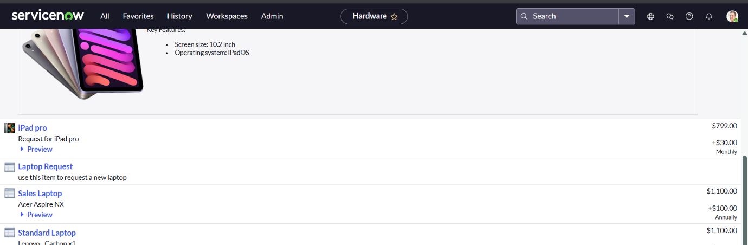

THEN UI ACTION FOR RESET THE FORM:

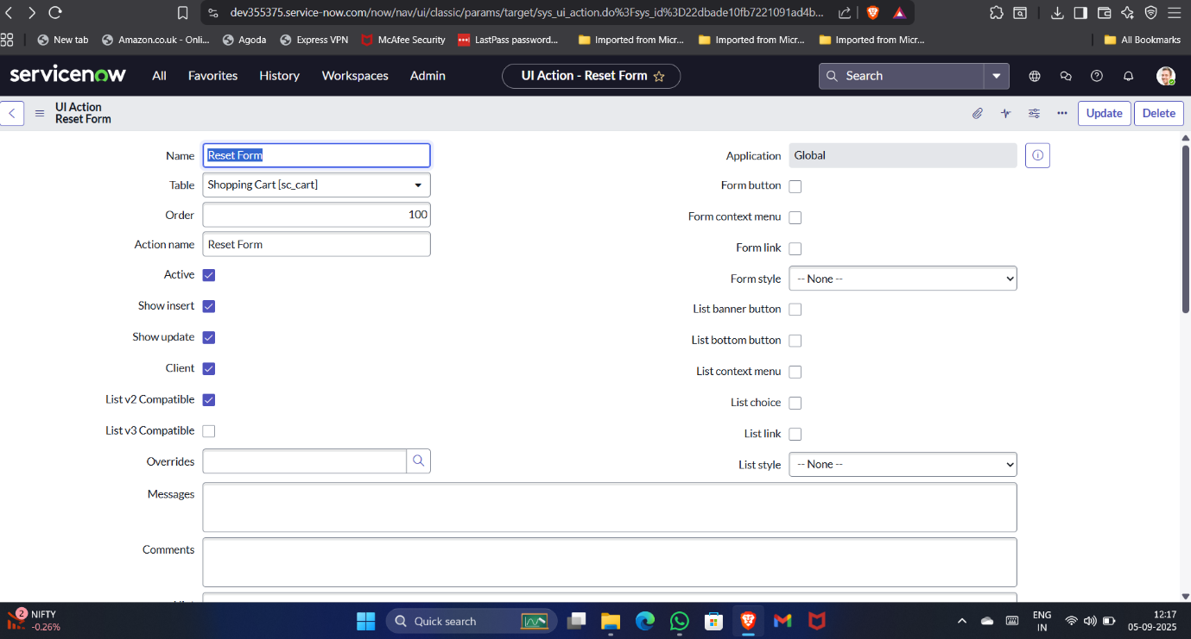

GO TO SERVICE CATALOG->HARDWARE

->LAPTOP REQUEST

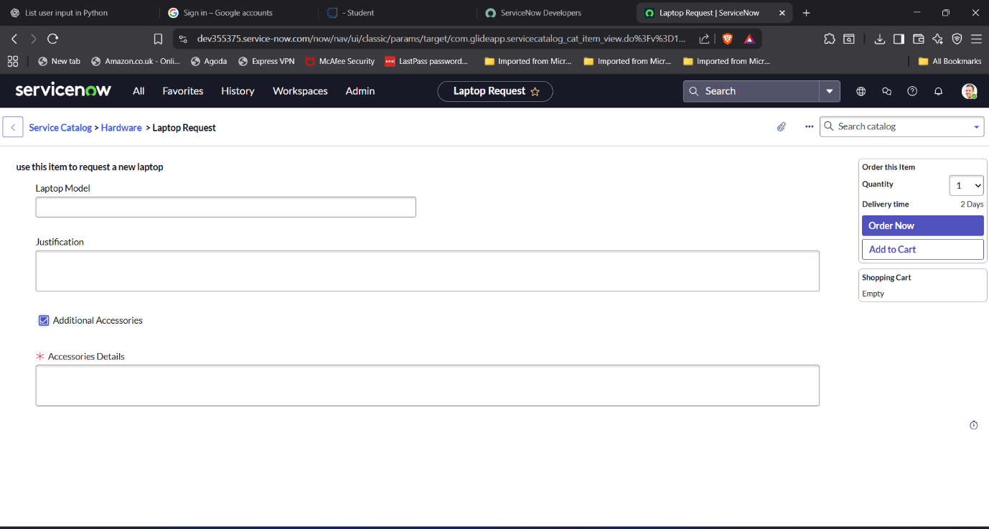

AFTER IN SMART INTERNZ LOGIN:

GO TO PROFILE->

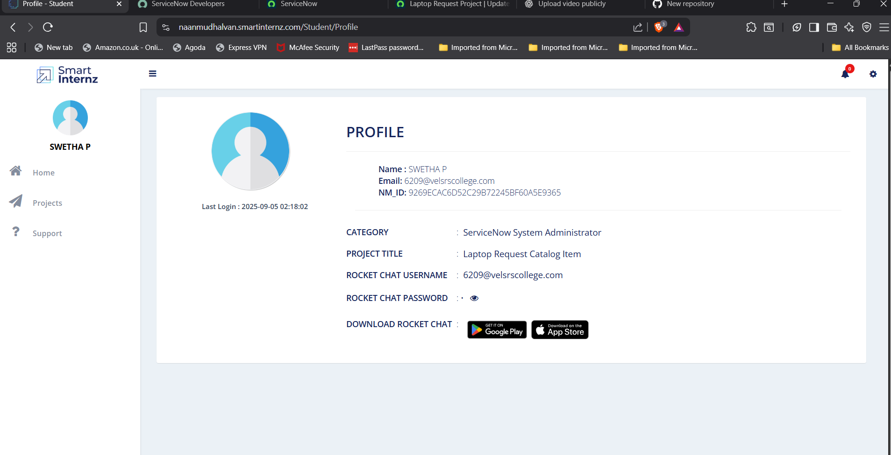

HERE, THE INSTRUCTIONS FOR PROJECT--🡪

THEN GO TO PROJECT WORKSPACE:

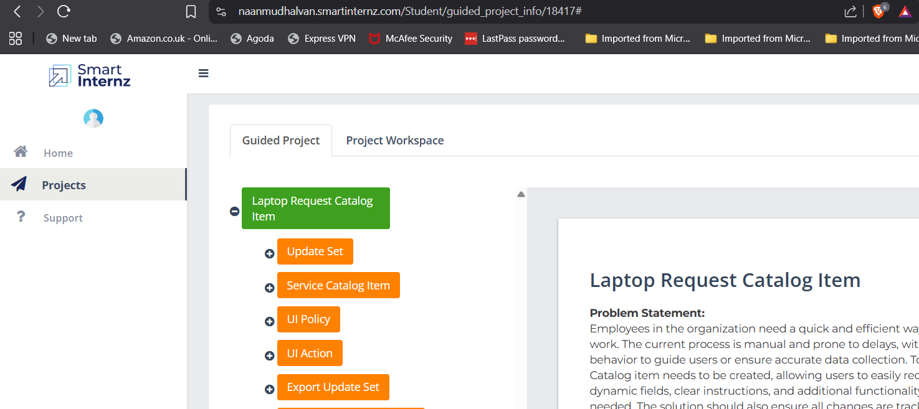

AFTER THE COMPLETION OF YOUR PROJECT YOU WILL GET 90% OF PROJECT PROGRESS VISIBLE:

